Nitesh Joshi
E23CSEU1970
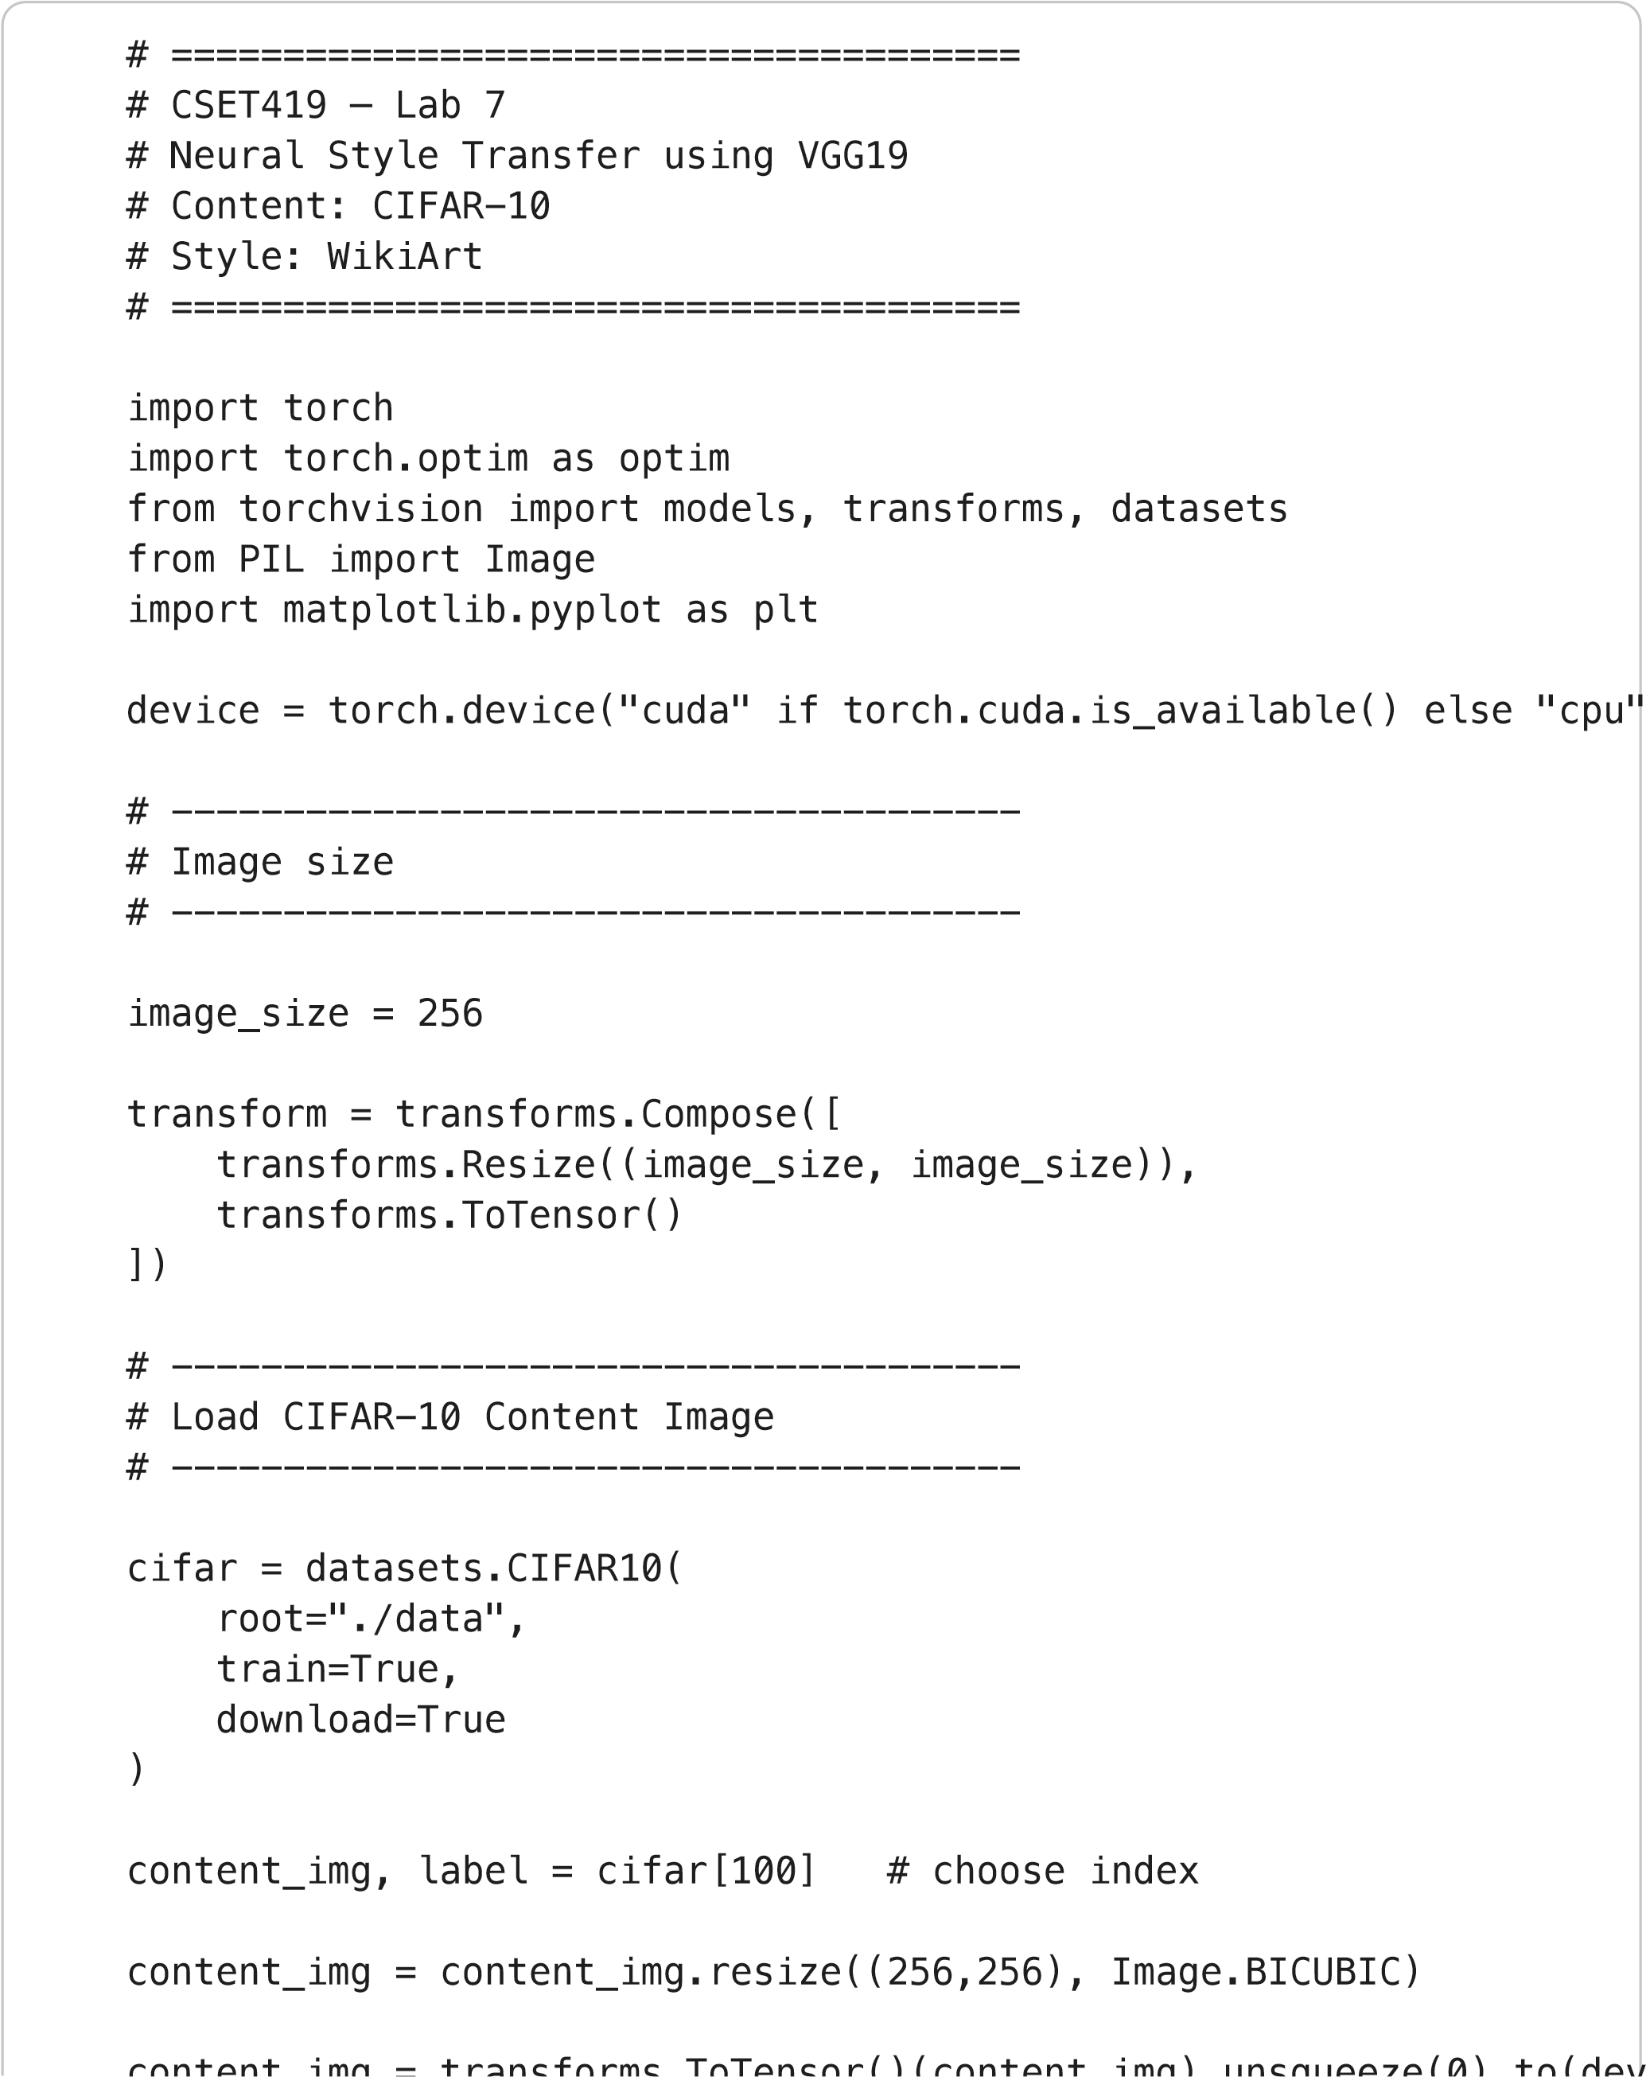
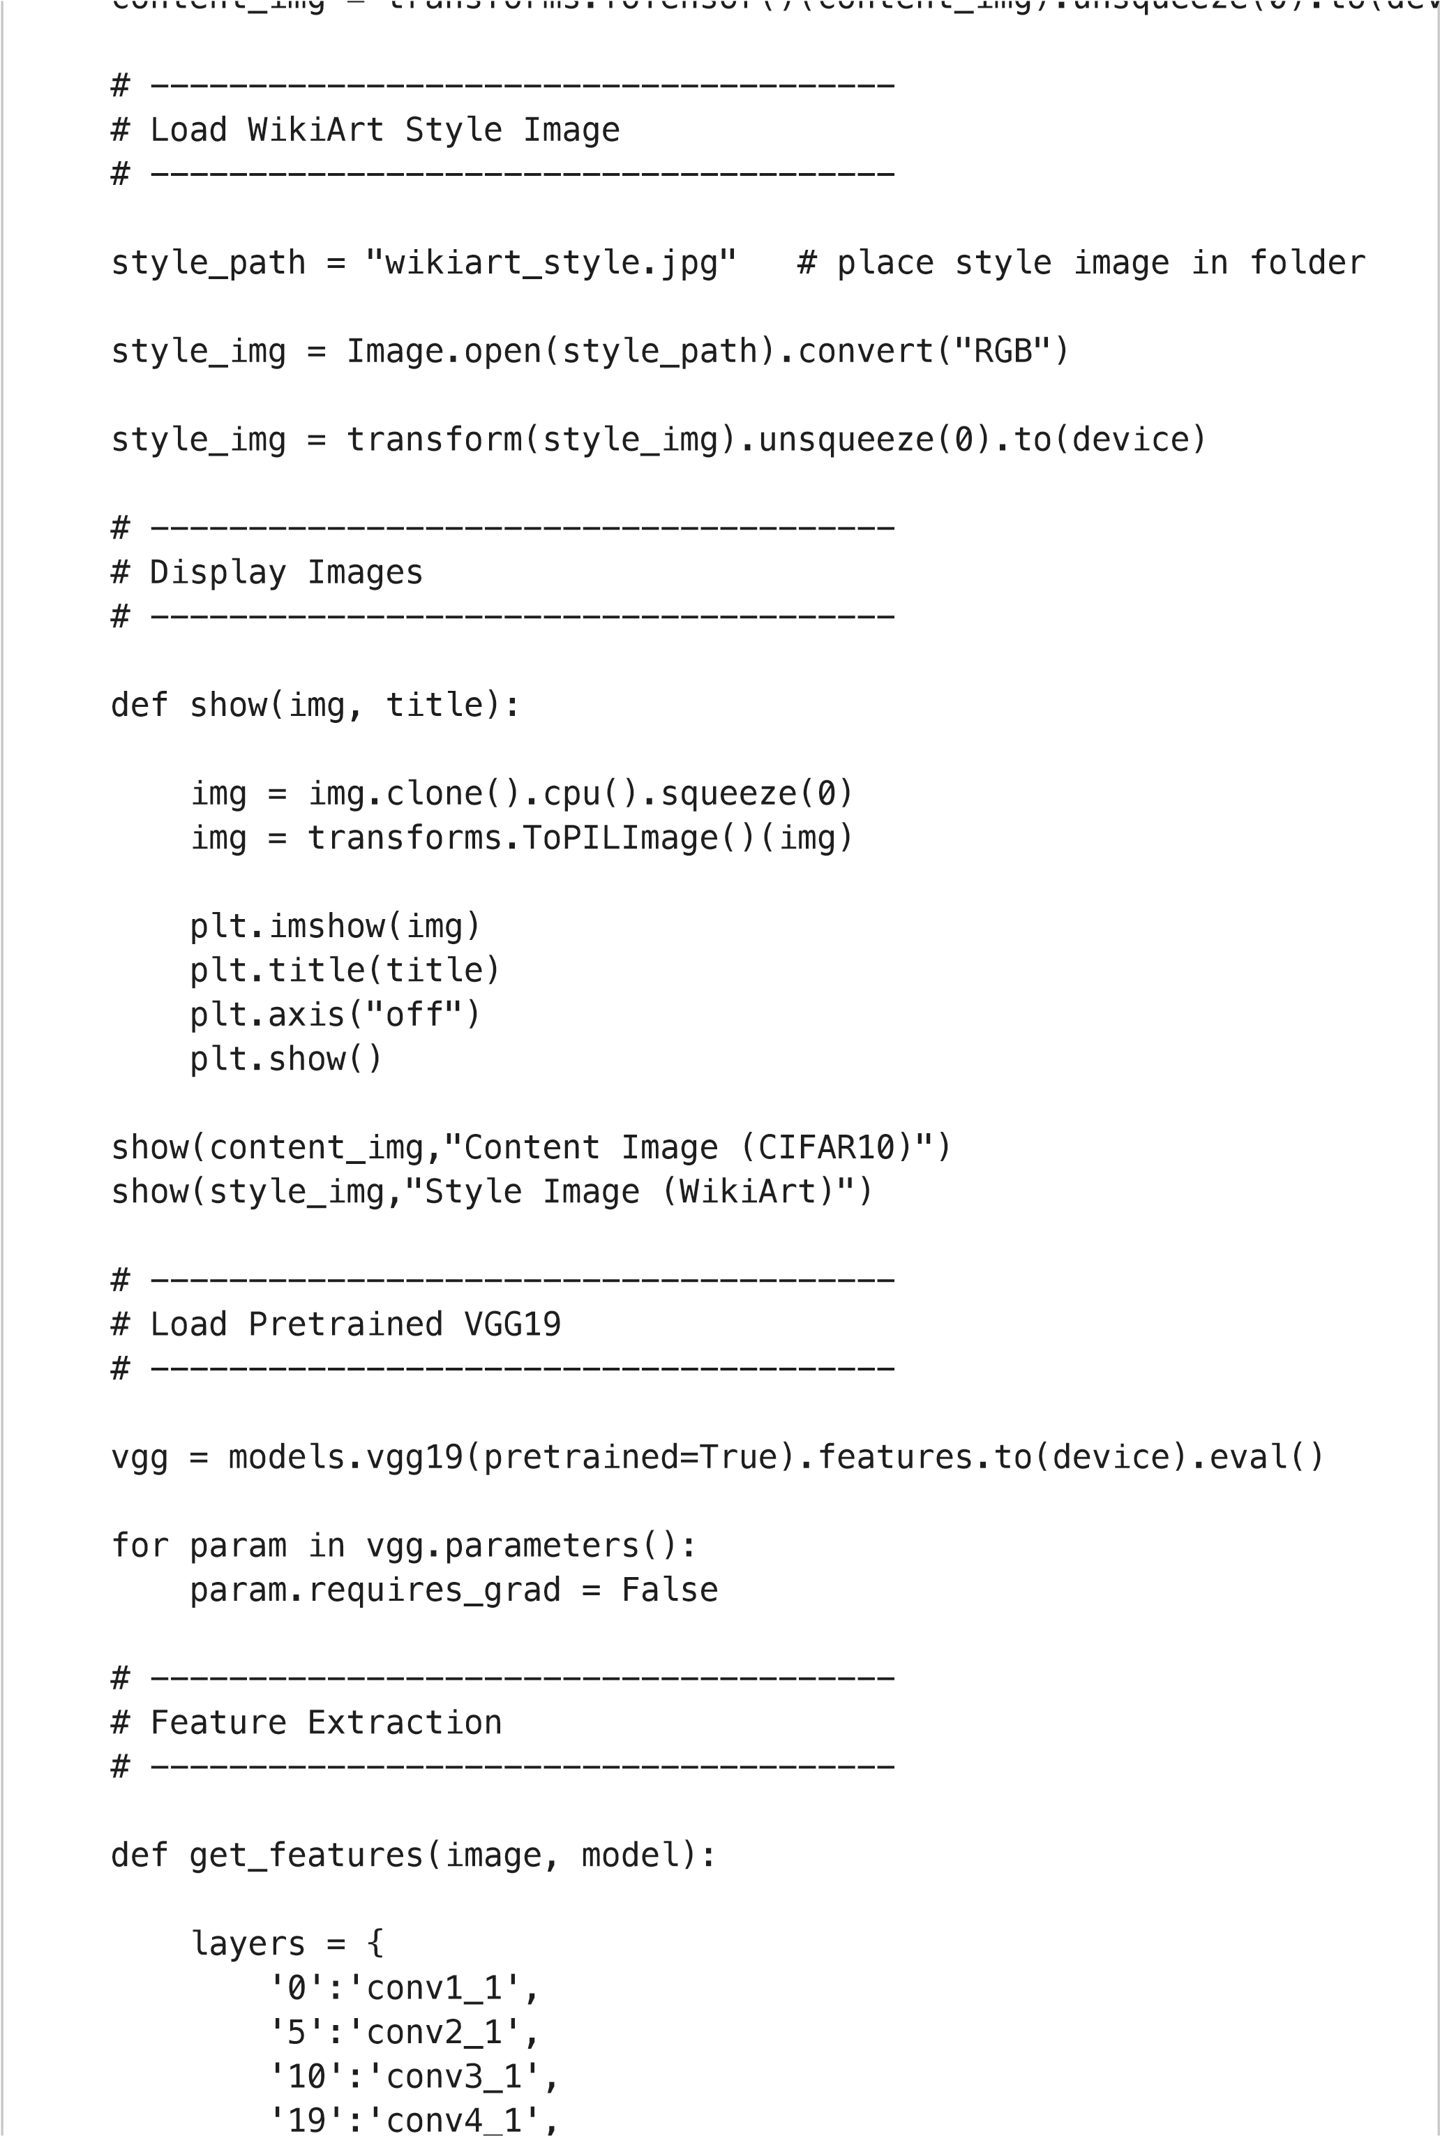
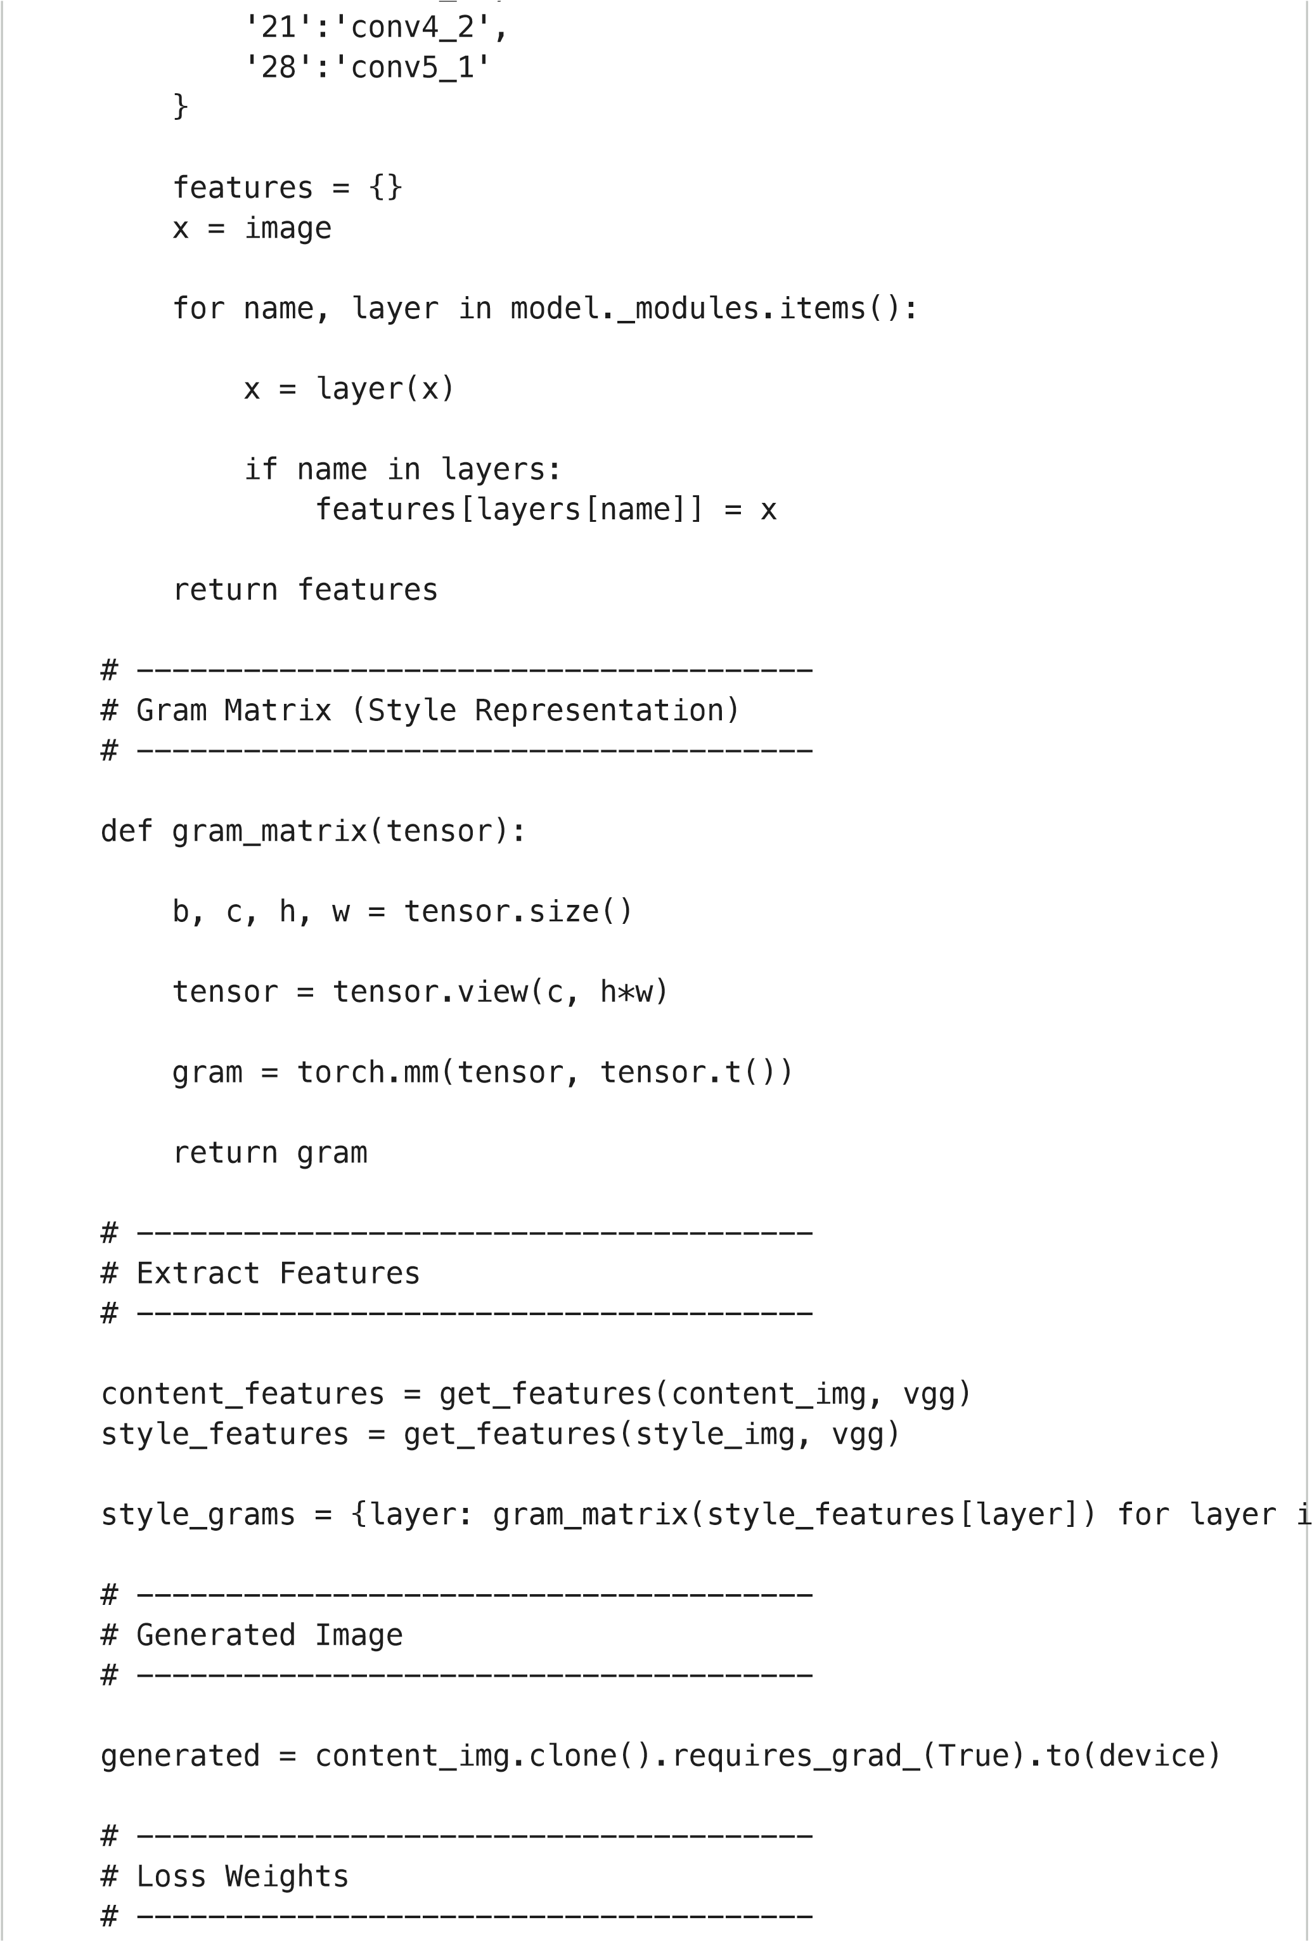
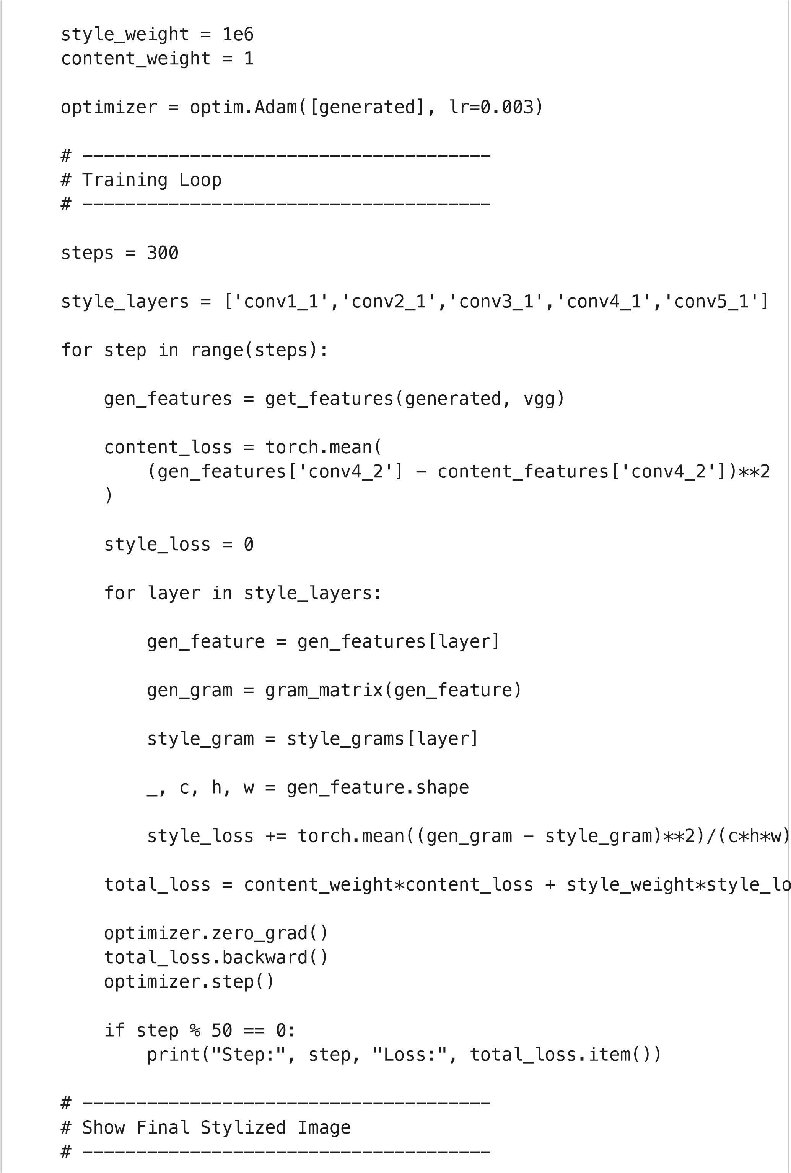
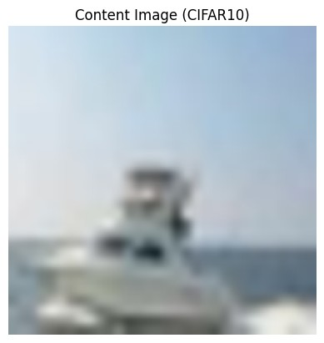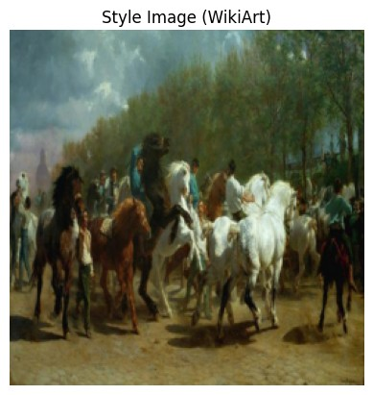

/usr/local/lib/python3.12/dist-packages/torchvision/models/_utils.py
warnings.warn(
/usr/local/lib/python3.12/dist-packages/torchvision/models/_utils.py
show
(
generated
,
"Stylized

Image"
)
/usr/local/lib/python3.12/dist-packages/torchvision/models/_utils.py
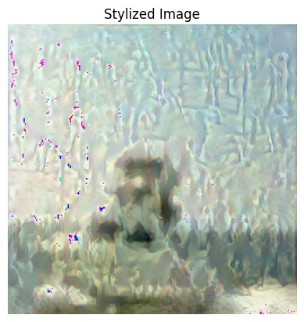
warnings.warn(msg)
Downloading: "
htt
p
s://download.p
y
torch.or
g
/models/v
gg
19-dcbb9e9d.
p
t
h
100
%|
██████████
| 548M/548M [00:03<00:00, 173MB/s]
Step: 0 Loss: 5873502.0
Step: 50 Loss: 367362.0
Step: 100 Loss: 217917.609375
Step: 150 Loss: 169876.453125
Step: 200 Loss: 142909.0625
Step: 250 Loss: 124579.484375

